Name-Mohammad Soban

University Rollo.-1922034

Subject-Mobile Application Development

Problem Statement-Develop an android application to demonstrate Implicit as well as Explicit Intent.

**Xml code for implicit intent**

*<?***xml version="1.0" encoding="utf-8"***?>*<**androidx.constraintlayout.widget.ConstraintLayout  
 xmlns:android="http://schemas.android.com/apk/res/android"  
 xmlns:tools="http://schemas.android.com/tools"  
 xmlns:app="http://schemas.android.com/apk/res-auto"  
 android:layout_width="match_parent"  
 android:layout_height="match_parent"  
 tools:context=".MainActivity"**>  
  
 <**EditText  
 android:id="@+id/editText1"  
 android:layout_width="wrap_content"  
 android:layout_height="wrap_content"  
 android:ems="10"  
 android:inputType="textPersonName"  
 android:minHeight="48dp"  
 app:layout_constraintBottom_toBottomOf="parent"  
 app:layout_constraintEnd_toEndOf="parent"  
 app:layout_constraintHorizontal_bias="0.497"  
 app:layout_constraintStart_toStartOf="parent"  
 app:layout_constraintTop_toTopOf="parent"  
 app:layout_constraintVertical_bias="0.202"** />  
  
 <**Button  
 android:id="@+id/button"  
 android:layout_width="130dp"  
 android:layout_height="48dp"  
 android:text="Click"  
 app:layout_constraintBottom_toBottomOf="parent"  
 app:layout_constraintEnd_toEndOf="parent"  
 app:layout_constraintHorizontal_bias="0.498"  
 app:layout_constraintStart_toStartOf="parent"  
 app:layout_constraintTop_toTopOf="parent"** />  
</**androidx.constraintlayout.widget.ConstraintLayout**>

**Java code for implicit intent**

**package** in.ac.gehu.com.example.implicitintent;  
  
**import** androidx.appcompat.app.AppCompatActivity;  
**import** android.os.Bundle;  
**import** android.app.Activity;  
**import** android.content.Intent;  
**import** android.net.Uri;  
**import** android.view.View;  
**import** android.widget.Button;  
**import** android.widget.EditText;  
  
**public class** MainActivity **extends** AppCompatActivity {  
 EditText **one**;  
 Button **b**;  
 @Override  
 **protected void** onCreate(Bundle savedInstanceState)  
 {  
 **super**.onCreate(savedInstanceState);  
 setContentView(R.layout.***activity_main***);  
 **one** = (EditText) findViewById(R.id.***editText1***);  
 **b**= (Button) findViewById(R.id.***button***);  
 **b**.setOnClickListener(**new** View.OnClickListener(){  
 @Override  
 **public void** onClick(View view)  
 {  
 String url = **one**.getText().toString();  
 Intent intent = **new** Intent(Intent.***ACTION_VIEW***, Uri.*parse*(url));  
 startActivity(intent);  
 }  
 });  
 }  
}

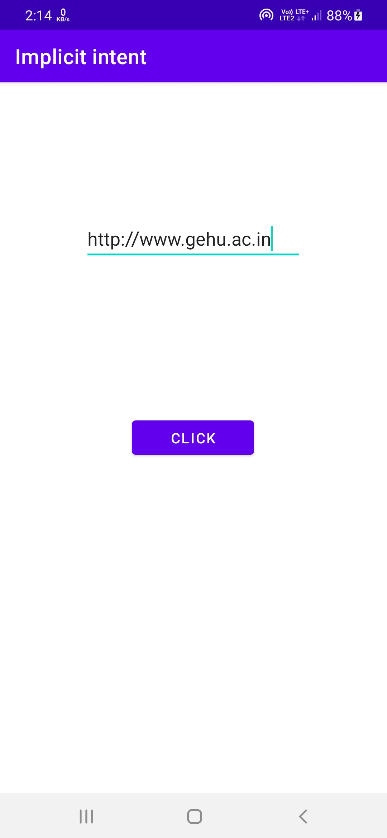



**Xml code for explicit intent of First Activity**

*<?***xml version="1.0" encoding="utf-8"***?>*<**androidx.constraintlayout.widget.ConstraintLayout xmlns:android="http://schemas.android.com/apk/res/android"  
 xmlns:app="http://schemas.android.com/apk/res-auto"  
 xmlns:tools="http://schemas.android.com/tools"  
 android:layout_width="match_parent"  
 android:layout_height="match_parent"  
 tools:context=".MainActivity"**>  
  
 <**TextView  
 android:id="@+id/textView"  
 android:layout_width="140dp"  
 android:layout_height="45dp"  
 android:text="First Activity"  
 app:layout_constraintBottom_toBottomOf="parent"  
 app:layout_constraintEnd_toEndOf="parent"  
 app:layout_constraintHorizontal_bias="0.498"  
 app:layout_constraintStart_toStartOf="parent"  
 app:layout_constraintTop_toTopOf="parent"  
 app:layout_constraintVertical_bias="0.212"** />  
  
 <**Button  
 android:id="@+id/button"  
 android:layout_width="wrap_content"  
 android:layout_height="wrap_content"  
 android:text=" Click for next Activity"  
 app:layout_constraintBottom_toBottomOf="parent"  
 app:layout_constraintEnd_toEndOf="parent"  
 app:layout_constraintStart_toStartOf="parent"  
 app:layout_constraintTop_toTopOf="parent"** />  
</**androidx.constraintlayout.widget.ConstraintLayout**>

**Java code for explicit intent of First Activity**

**package in.ac.gehu.com.example.explicitintent;  
  
import androidx.appcompat.app.AppCompatActivity;  
import android.os.Bundle;  
import android.app.Activity;  
import android.content.Intent;  
import android.view.View;  
import android.view.View.OnClickListener;  
import android.widget.Button;  
  
public class MainActivity extends AppCompatActivity {  
 Button button;  
  
 @Override  
 protected void onCreate(Bundle savedInstanceState) {  
 super.onCreate(savedInstanceState);  
 setContentView(R.layout.*activity_main*);  
 button = (Button)findViewById(R.id.*button*);  
 button.setOnClickListener(new OnClickListener() {  
 public void onClick(View view)  
 {  
 Intent i = new Intent(getApplicationContext(),  
 MainActivity2.class);  
 startActivity(i);  
 }  
 });  
 }  
}**

**Xml code for explicit intent of Second Activity**

*<?***xml version="1.0" encoding="utf-8"***?>*<**androidx.constraintlayout.widget.ConstraintLayout xmlns:android="http://schemas.android.com/apk/res/android"  
 xmlns:app="http://schemas.android.com/apk/res-auto"  
 xmlns:tools="http://schemas.android.com/tools"  
 android:layout_width="match_parent"  
 android:layout_height="match_parent"  
 tools:context=".MainActivity2"**>  
  
 <**TextView  
 android:id="@+id/textView2"  
 android:layout_width="115dp"  
 android:layout_height="27dp"  
 android:text="Second Activity"  
 app:layout_constraintBottom_toBottomOf="parent"  
 app:layout_constraintEnd_toEndOf="parent"  
 app:layout_constraintHorizontal_bias="0.473"  
 app:layout_constraintStart_toStartOf="parent"  
 app:layout_constraintTop_toTopOf="parent"  
 app:layout_constraintVertical_bias="0.182"** />  
  
 <**Button  
 android:id="@+id/button2"  
 android:layout_width="wrap_content"  
 android:layout_height="wrap_content"  
 android:text="Click for previos Activity"  
 app:layout_constraintBottom_toBottomOf="parent"  
 app:layout_constraintEnd_toEndOf="parent"  
 app:layout_constraintStart_toStartOf="parent"  
 app:layout_constraintTop_toTopOf="parent"** />  
</**androidx.constraintlayout.widget.ConstraintLayout**>

**Java code for explicit intent of Second Activity**

**package** in.ac.gehu.com.example.explicitintent;  
  
**import** androidx.appcompat.app.AppCompatActivity;  
**import** android.content.Intent;  
**import** android.os.Bundle;  
**import** android.view.View;  
**import** android.view.View.OnClickListener;  
**import** android.widget.Button;  
  
  
**public class** MainActivity2 **extends** AppCompatActivity {  
 Button **button2**;  
 @Override  
 **protected void** onCreate(Bundle savedInstanceState) {  
 **super**.onCreate(savedInstanceState);  
 setContentView(R.layout.***activity_main2***);  
 **button2** = (Button)findViewById(R.id.***button2***);  
 **button2**.setOnClickListener(**new** OnClickListener() {  
 **public void** onClick(View view)  
 {  
 Intent i = **new** Intent(getApplicationContext(),  
 MainActivity.**class**);  
 startActivity(i);  
 }  
 });  
 }  
}

**OUTPUT-**

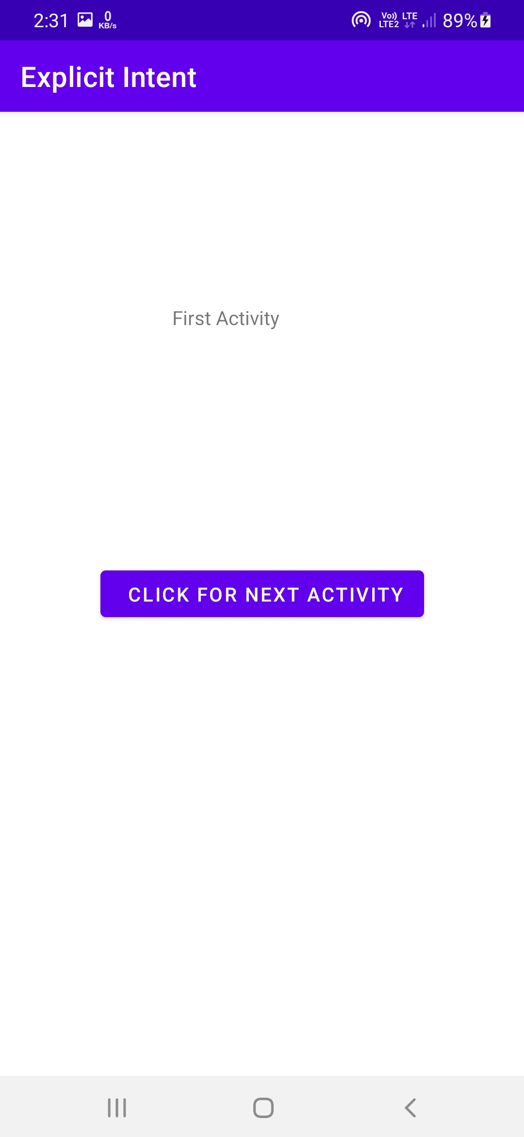

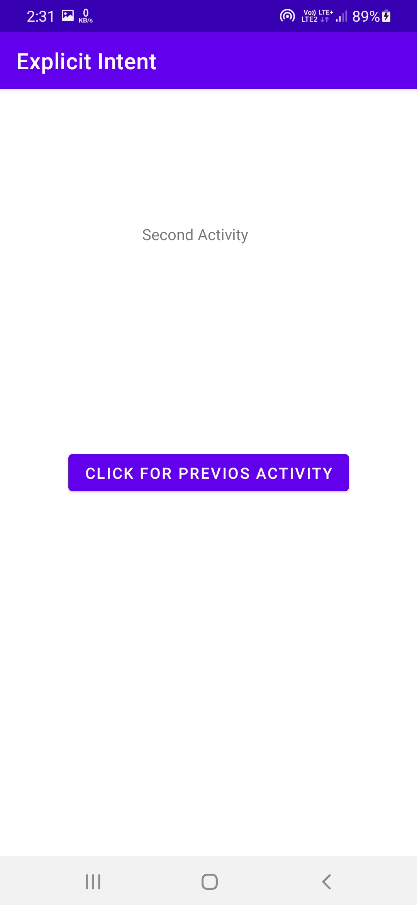

PROBLEM STATEMENT 2- Develop an android application to demonstrate activity life cycle using logcat.

import android.support.v7.app.AppCompatActivity;

import android.os.Bundle;

import android.widget.Toast;

public class MainActivity extends AppCompatActivity {

    @Override

    protected void onCreate(Bundle savedInstanceState) {

        super.onCreate(savedInstanceState);

        setContentView(R.layout.activity_main);

        Toast toast = Toast.makeText(getApplicationContext(), "onCreate Called", Toast.LENGTH_LONG).show();

    }

    protected void onStart() {

        super.onStart();

        Toast toast = Toast.makeText(getApplicationContext(), "onStart Called", Toast.LENGTH_LONG).show();

    }

    @Override

    protected void onRestart() {

        super.onRestart();

        Toast toast = Toast.makeText(getApplicationContext(), "onRestart Called", Toast.LENGTH_LONG).show();

    }

    protected void onPause() {

        super.onPause();

        Toast toast = Toast.makeText(getApplicationContext(), "onPause Called", Toast.LENGTH_LONG).show();

    }

    protected void onResume() {

        super.onResume();

        Toast toast = Toast.makeText(getApplicationContext(), "onResume Called", Toast.LENGTH_LONG).show();

    }

    protected void onStop() {

        super.onStop();

        Toast toast = Toast.makeText(getApplicationContext(), "onStop Called", Toast.LENGTH_LONG).show();

    }

    protected void onDestroy() {

        super.onDestroy();

        Toast toast = Toast.makeText(getApplicationContext(), "onDestroy Called", Toast.LENGTH_LONG).show();

    }

}